Writing Robot (2021)

Preface
This project was from a few years ago, so I’m digging through some blurry linear-algebra memories here. If I ever get more time, I’d like to come back, derive all the math cleanly, and update this page.
Originally, this was supposed to be a hands-on physical robot build with, electronics, and fabrication. Then COVID hit, we ended up working withCoppeliaSim as a simulation environment.
My part of the project was the programming, robot math.
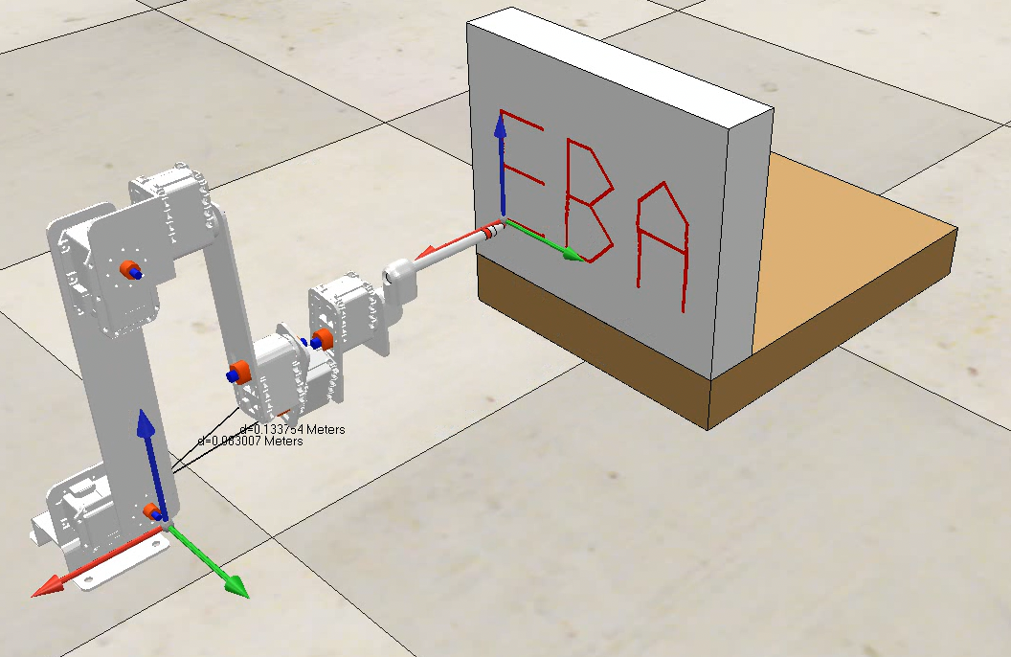

CoppeliaSim – the simulation environment
We used CoppeliaSim to run the actual 3D simulation. It handled:
- Robot kinematics
- Joint motion
- Pen movement
- Collision checking
- Sensors and environment

MATLAB – the controller / brain
All the logic lived in MATLAB:
- Path planning
- Inverse kinematics
- Trajectory generation
- Talking to CoppeliaSim

Background — Quick Robotics Terminology

Forward Kinematics (FK)
This is the process of taking the robot's known joint variables, like the angles for rotating joints and calculating the exact position and orientation of the end-effector (the pen in this case) in the 3D workspace.

Inverse Kinematics (IK)
IK is the opposite, given a desired end-effector pose, what joint angles produce that pose?
There are two big types:
- Analytical IK – closed-form math solutions (fast, exact, but only works for special robot geometries)
- Numerical IK – iterative solvers (slower but works for almost anything), this project used this.
Open-source analytical IK generators exist, like:
- https://github.com/rpiRobotics/ik-geo
- https://github.com/uw-biorobotics/IKBT
…but they only work for robots with solvable closed-form IK.
Most modern robotics libraries use numerical IK for general cases (like Modern Robotics Textbook, which most of this is based on).

Basic Robot Setup
Before doing anything fancy, we had to define the robot mathematically:
- Link lengths (L1, L2, …)
- Screw axes (Slist)
- Home configuration (M matrix)
- Joint limits
- Writing plane transform (board frame)
We also had to define:
- Letter sequence (word to draw)
- Letter spacing
- Local XY point sets for each character

Trajectory Generation
Here’s the fun part where the robot figures out how to draw letters.

1. Load letter shapes
Each letter (A, B, C, O…) is stored as a small set of XY points.

2. Transform into the writing board frame
We use a T matrix to convert local letter points → positions on the global writing surface.

3. Interpolate the trajectory
Break the letter curves into very small steps (the smaller the step, the smoother the robot draws).

Inverse Kinematics Pipeline
For each tiny step of the trajectory:
- Use IKinSpace or IKinBody to solve θ
- Use the previous solution as the next initial guess
- If it fails → add small random noise to the guess and retry

Final Output
